**Creating and deploying a sharded cluster**

Create 2 folders configdb1 and configdb2

mkdir configdb1

mkdir configdb2

Let’s start config server instances.

**mongod –configsvr –replSet rs1 –dbpath “path of confidb1 dir” –port 27019**

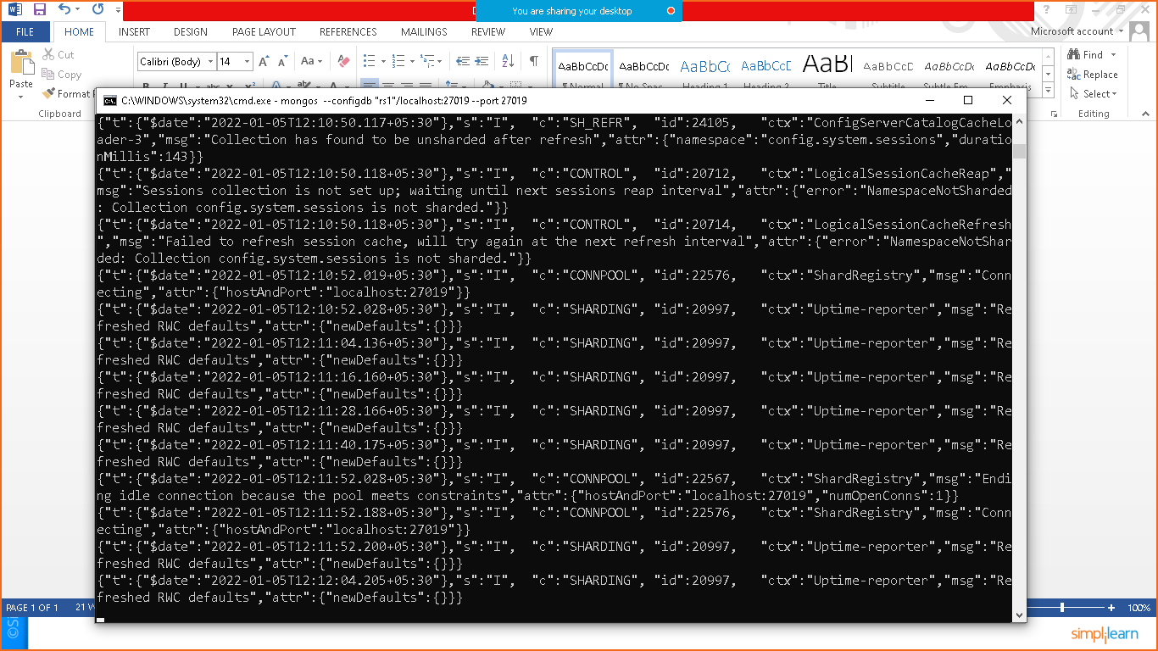

**mongod –configsvr –replSet rs1 –dbpath “path of confidb1 dir” –port 27010**

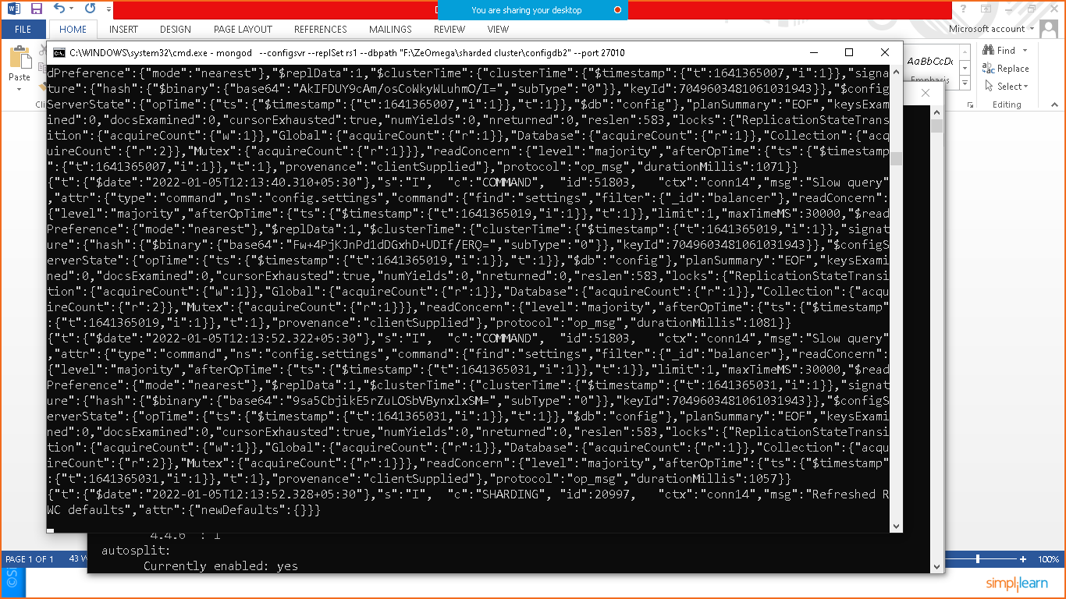

Let’s connect to mongo shell

mongo –port 27019

Initiate rs configuration

rs.initiate({_id:”rs1”,members:[{_id:0,host:”localhost:27019”},{_id:1,host:”localhost:27010}]})

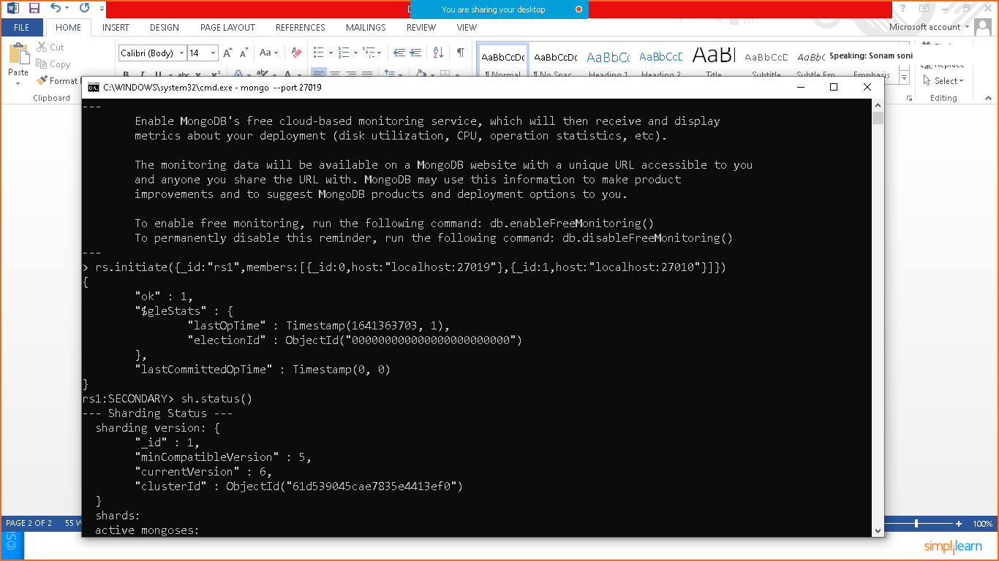

Open another terminal and execute below mentioned command

mongos –configdb “rs1”/localhost:27019 –port 27019

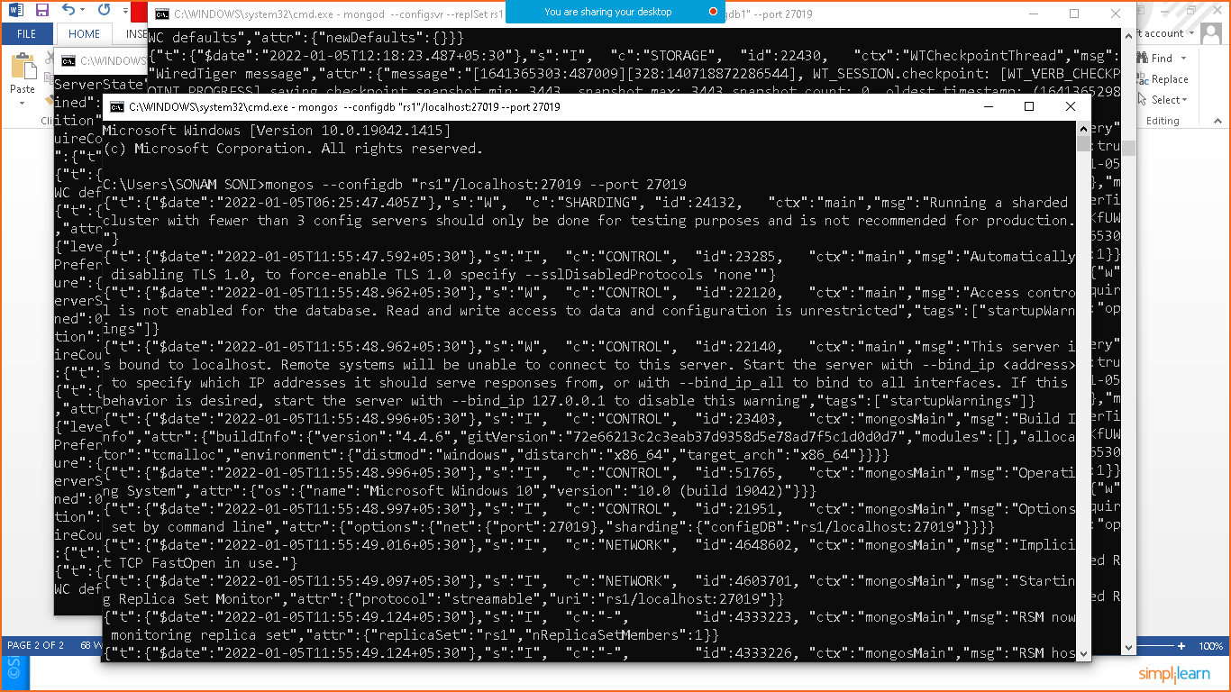

Go to the terminal where you have executed mongo –port 27019 command

Execute

sh.status() to check sharding status.

